LAB Instruction

What You Will Learn
- How to use flex-box
- How to use CSS-grid layout

CSS Layout
Yasaman Amannejad, 2020
Modified PJ Perri, 2023
And again by Jim Davis 2024

Instructions
In this lab, you will complete two activities. The instructions for the first activity contain most of the required steps for the activity. It is developed to make sure that you have understood flex and grid layouts.
After completing task 1, you will be challenged in task 2 to design an advanced page layout.

Task 1
In this task, you are asked to use CSS to style the layout of a Website. Please download and unzip the given code for lab (startingPoint07.zip) and follow these steps:

- The initial layout for the page is given. Open the index.html and the given CSS file and read the code to understand how it is created. Gridlines are shown in the following picture.

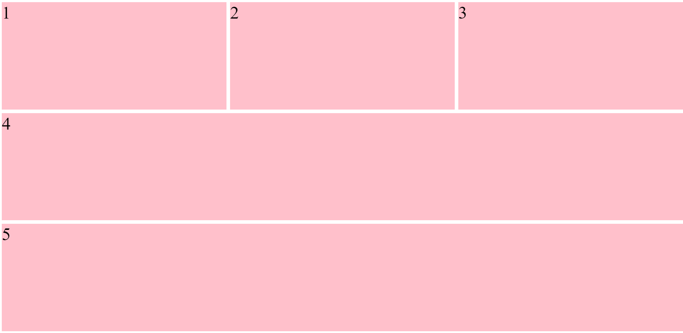

- Change the row and column sizes:
  - Change the column weights to be 1, 10, 1.
  - Change the row weights to be 2, 10, 1.

- Add gaps between gird cells (grid-gap: 10px). Your layout should look like this:

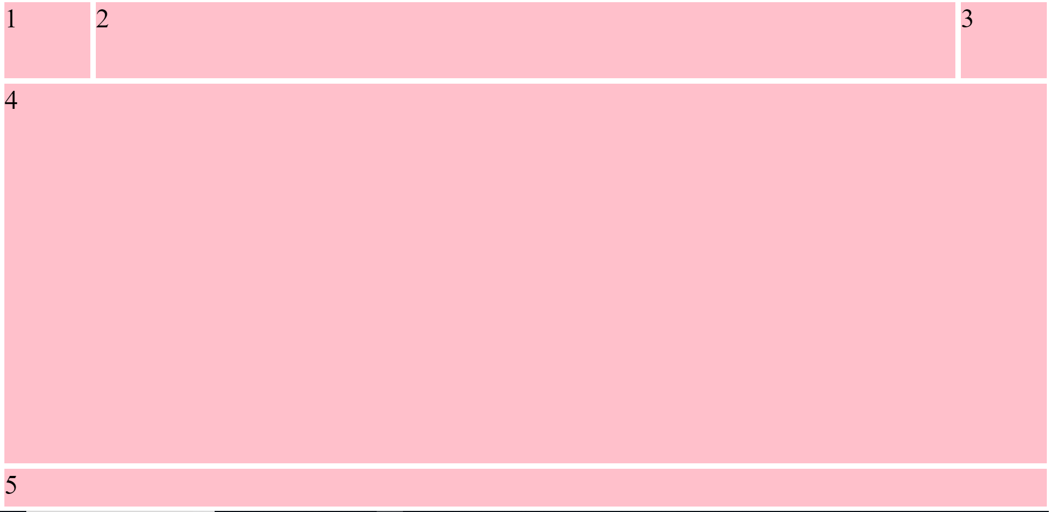

- Read the code to understand how sections 4 and 5 are covering multiple columns
Think about these: How many columns item4 is covering? How many rows item4 is covering?

#item4{
grid-column: 1/4;
}
#item5{
grid-column: 1/4;
}

- The section (item4) will contain the main content of the page. Change the overflow of this item to be “auto”, to be scrollable if a long content is added to this section.

#item4{
grid-column: 1/4;
/*the content will be scrollable*/
overflow:auto;
}

- Creating a menu in the navigation bar.
  - Add the following code to your html file..
<nav class="item" id="item2">
<div class="menu">Home</div>
<div class="menu">About</div>
<div class="menu">News</div>
<div class="menu">Services</div>
</nav>

  - Using CSS Flexbox, modify the menu bar to look like this:

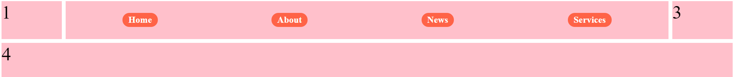

- Now, we want to divide the middle section (item4) into smaller areas. To do this:
  - Change the display of item4 to grid.
  - Define correct values for grid-template-rows and grid-template-columns to create a grid layout inside item 4 that looks like the following image.
How many rows and columns do you need to create this layout?
Note: If you need to create many columns or rows of the same size, you may need to use a short format. Here is a short format for defining 9 columns of the same size:

grid-template-columns: repeat(9,1fr);

item4

  - Add four divs inside item 4.

  - Define grid-gap of 10px for this area.

  - Add what is needed for item4, to make this item a CSS grid wrapper with 3 rows and 9 columns.

#item4{
grid-column: 1/5;
overflow:auto;
background-color: white;

display:grid;
grid-template-rows: repeat(3,1fr);
grid-template-columns: repeat(9,1fr);
grid-gap:20px;
}

  - Do not forget that you need to define properties for item6-9 to set them in their correct places in the grind inside item 4.

Your final page should look like this:

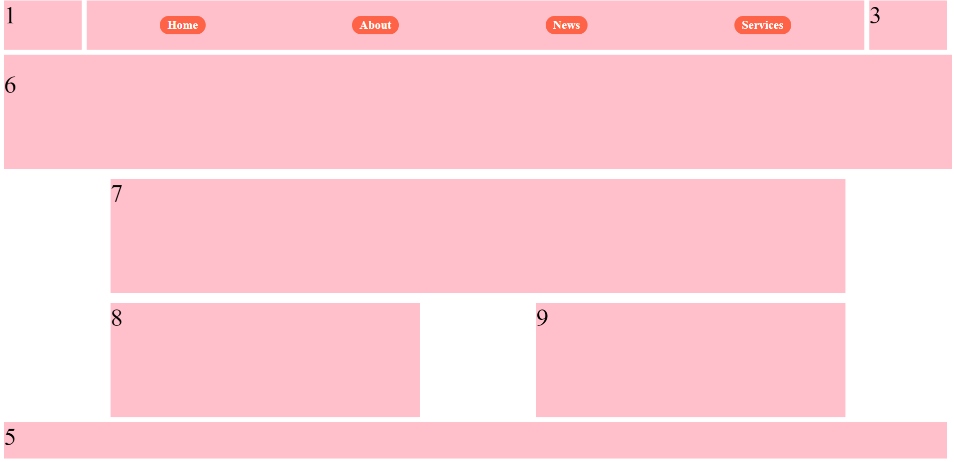

Task 2
In this project, you will need to implement a layout using CSS Grids. You have been provided with dashboard.html file as well as a CSS file with some but not all styling you will need. The charts are provided as 8 static image files. The icons are a series of SVG files.

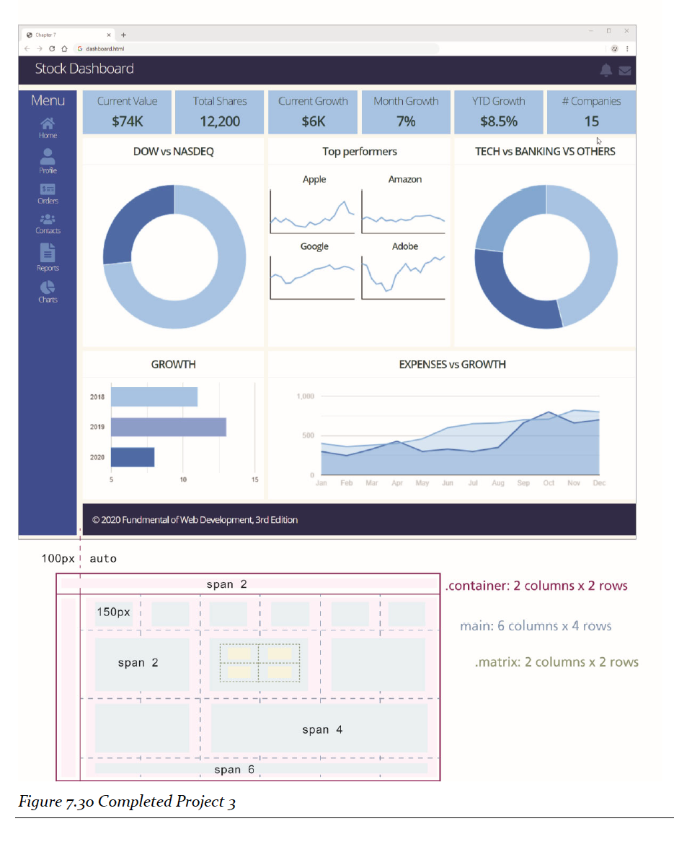
Suggestions:

- You will likely need a series of nested grids to implement this layout. While there are multiple ways to implement this layout, the instructions here provide a relatively clear approach.
  - The top level (in the markup contained within <div class=container>), contains two rows of two columns each; the first row spans both columns.
  - The other content fits into the second row.
  - A grid‐gap of 10px was used throughout.

- The two icons on the right side of the header bar can be positioned using grid layout, flexbox layout, positioning, or simple floats.
  - Try using all four methods. Which do you like best? Why?
  - The icons should always be flush on the right side of the browser window.

- The content inside the left‐side navigation bar can be styled in different ways using grid layout, flexbox layout, or simple box formatting (margin, padding, etc). I would recommend using Flex to get some more practice with it. Flexbox is often used to style content within a CSS grid cell.

- The main content (inside the <main> element) will consist of another nested grid with 6 columns and 4 rows.

- Some of the individual cells will have to span multiple columns. For example, the footer row spans all 6 columns.

- The four Top Performer charts will be within another nested grid with two rows and columns.

- Be sure to check out how your browsers display dashboard.html.

Summary
Which of the four methods did you preferred to position the two icons – can you explain why you felt that way.

